**Gaps are commonly observed in a sequence alignment. Briefly describe why gaps are important in sequence alignment, and what biological phenomena could have caused this observation in an alignment?**

Gap allows for maximisation of similarity of sequences, i.e. adjusting the residue positions using gap allow for more identical residues to match up. This is caused by insertions and/or deletions (sometimes this is referred to as indels).

**Why is sequence conservation (or homology) commonly observed at the protein level? Give TWO (2) reasons.**

Multiple codons code for the same amino acid (codon degeneracy issue), thus DNA sequences do not adequately capture the conservation of gene function exhibited at the protein level.

Protein sequences also have a larger alphabet size (i.e. 20 amino acids) compared to DNA (4 bases), so the information content of protein sequences is greater.

**Name one limitation of the progressive multiple sequence alignment approach and suggest an alternative approach to address this limitation. (2 marks)**

Limitation: Errors in the early steps of progressive MSA are fixed and propagated throughout the process.

Alternative: refine the earlier alignments iteratively and see if better alignments (i.e. alignments with higher scores) can be achieved (i.e. the iterative progressive MSA approach).

**Describe one reason why RNA-sequencing may be more advantageous than microarray technology for capturing gene expression data. (3 marks)**

RNA-seq covers entire transcriptome without relying on a reference; more information can be extracted e.g. splicing, SNPs, non-coding RNAs; greater sensitivity in estimating expression than microarrays.

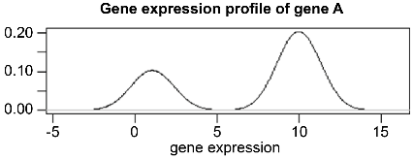**The plot below shows the gene-expression distribution for Gene A in a population of 1000 cells, as observed in a single cell RNA-sequencing experiment.**

There are two sub-populations within the 1000 cells that express different levels of Gene A.

**Name the open source project that contains comprehensive bioinformatics software in the R language.** Bioconductor

**Name two (2) computational approaches for gene finding.**

Intrinsic (or ab initio), Homology-based (based on sequence similarity)

**Name four (4) specific sequence features of eukaryotic genes that can be incorporated into a Hidden Markov model for predicting protein-coding genes. (4 marks)** (motifs of) splice site, Poly-A site, (sequence characteristics of) promoter region, codon usage bias, presence of ORFs (and any other plausible features).

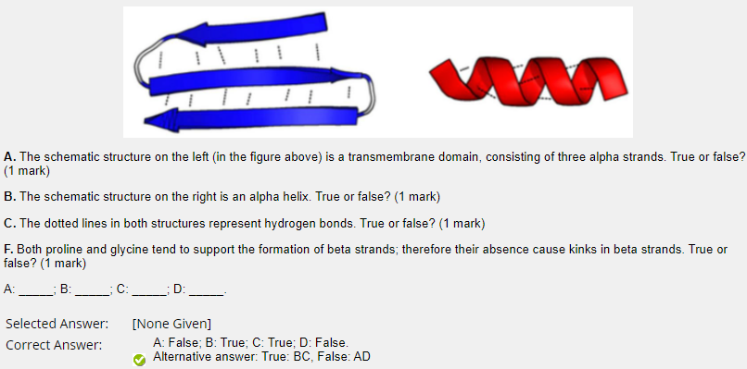

**Which of the following properties of a phylogenetic tree are an indication of insufficient evidence to resolve a tree during phylogenetic inference?** Multifurcating branch points.

**Gene Ontology is organised in three structured, species-independent ontologies. Name these three ontologies** Biological Process (2/3), Molecular Function (2/3), Cellular Component (2/3).

**Sequence Analysis**

**What is homology? Orthology? Paralogy?**

The study of a common evolutionary origin. Same origin, different species. Same origin, same species.

**What does a phylogenetic tree represent? What does “unrooted”, “ultra-metric”, “additive” mean for a tree?**

Evolutionary relationships; descendent, time/distance. An ultra-metric tree has a root, and a constant rate of mutation along all branches; additive trees indicate progress of divergence of species additively.

**What is an evolutionary model?** Describes how sequences change often relative time/rate of evolution

**How do we infer a phylogenetic tree?**

Sequence similarity gives alignment; Evolutionary models explain differences; Measuring distances; pairing, clustering, inferring ancestor states.

**What are “sequence motifs”?**

Short (often linear) sequence snippets, statistically enriched, carry function/structural characteristics; not necessarily strongly conserved.

**How can we represent motifs and how does searching for them work?**

Consensus; reg. expression; PWM. Matching by window over sequence; prob. Score.

**What is a sequence logo and why is it informative?**

Visualisation. Displays level of agreement/level of unpredictability or information entropy in each “column” by

“height of stack”, shows striking/dominant feature/s.

**What method finds “labels” of nodes in a tree?**

Maximum parsimony; ML and other prob models.

**Why is sequence conservation (or homology) commonly observed at the protein level? Give two reasons.**

Codon degeneracy issue – codon is triplet – multiple codons may code for the amino acid

4 nucleotides (A, C, G, T) vs. 20 amino acids (so there are greater diversity and they are much more informa content)

**“Two protein sequences that share 99% identity are 99% homologous, and 1% non-homologous.” Do you agree?**

No. homology is a statement, 2 seqs are either homologous or not, there's no extent of homology.

**Provide one reason why log-adds scores are used in most substitution matrices.**

We can sum them up, instead of dealing with multiplication of probability.

**Name a key difference between a global alignment and a local alignment.**

Global: comparing whole sequences | Needleman-Wunsch | less prone to give us false homology.

Local: localised similar regions | Smith-Waterman | more prone to give us false homology.

**PAM and BLOSUM are two commonly used scoring matrices for amino acid substitutions. Name one key difference between PAM and BLOSUM.**

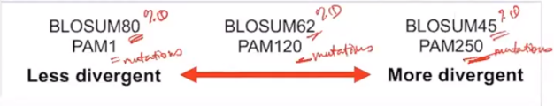PAM, the smaller the unit, the more different the sequences are, the number is number of mutations. BLOSUM, the higher number suggest the higher similarity, so this is because this number is percent identity.

The smaller the unit in PAM, the more similar sequences are, whereas the larger the value in BLOSUM more similar sequences are.

**Marcy would like to align two protein seqs that share less than 25% identity. She decided to use PAM1 as the scoring matrix. Do you think the PAM matrix she has chosen is appropriate in this case? Briefly explain why.**

No. Maybe PAM250. Based on highly similar sequences is, this based on sequences that share 85% identity or more, so given that Marcy wants to compare sequences they share less than 25% identity, then PAM1 would not be appropriate.

**Gaps are commonly observed in a sequence alignment. Briefly describe why gaps are important in sequence alignment, and what biological phenomena could have caused this observation in an alignment.**

In sequence alignment, we want to maximize similarity between or among the sequences that we're comparing, so gap would help us do that, so that the similar regions will be aligned together.

From the biological perspective, it reflects the insertions and deletions that would have occurred during the evolutionary history of the sequences.

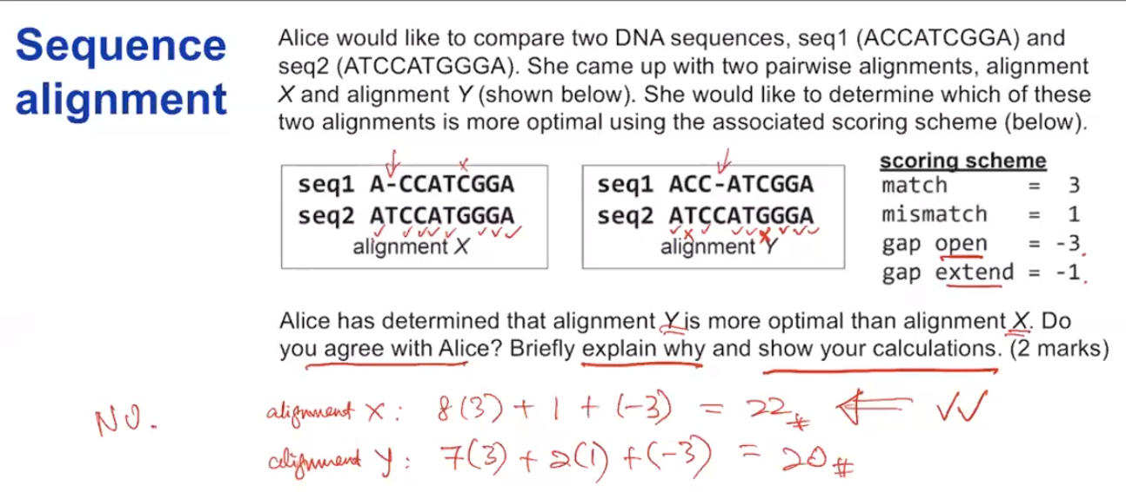 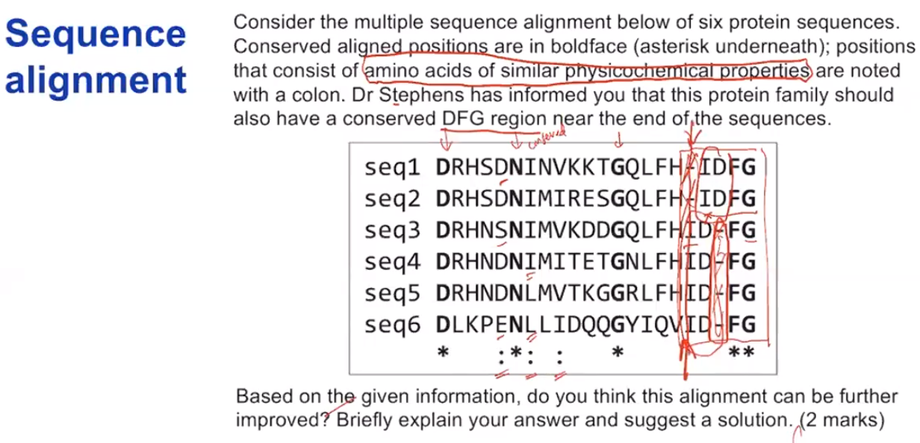

we don't need to have a column of gap, because you know gap is a penalty will just reduce the score.

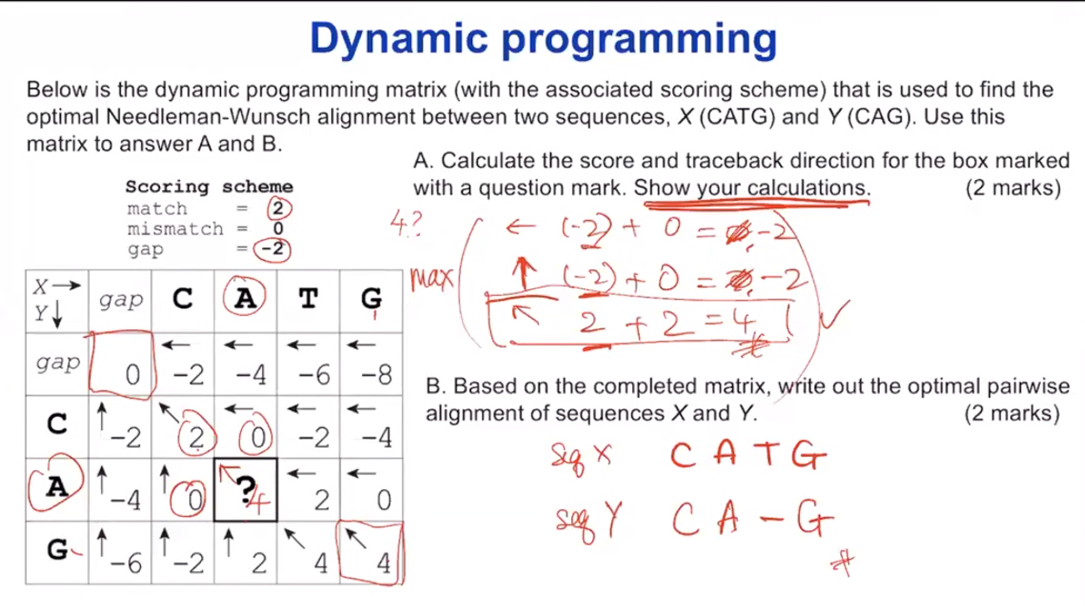

**Name one key limitation of progressive multiple sequence alignment.** Errors get propagated.

**Name two key approaches adopted in Clustal to establish the hierarchical order for which sequences are progressively aligned.** UPGMA + Neighbour joining

**Most multiple sequence alignment (MSA) approaches are based on progressive and iterative methods. Name two other MSA approaches.** - Consensus(T-COFFEE)– HMM

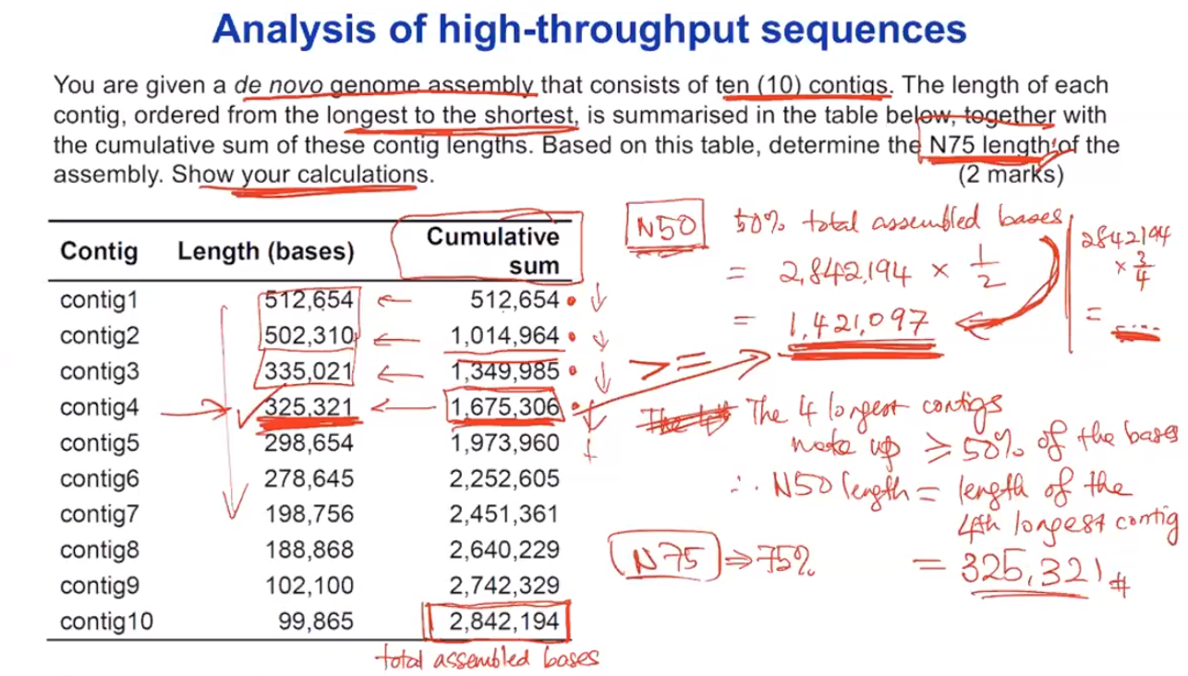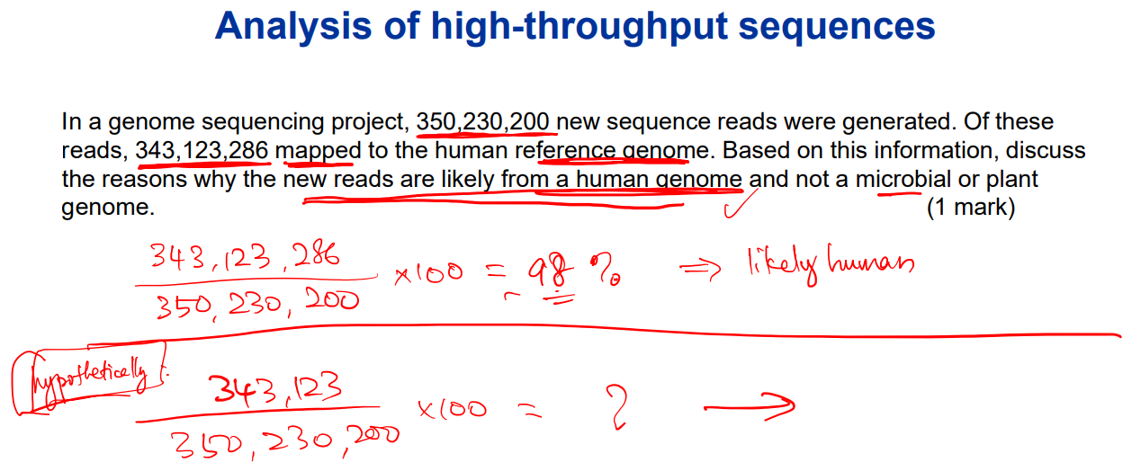

**Name a type of a continuous representation of a motif. Briefly explain one advantage of representing a motif using a continuous approach.** Sensible to frequency of character; Enable matches to be ranked

**Consider the following alignment of six proteins. Shaded positions are known to be functional, and the alignment illustrates that they are also conserved.** 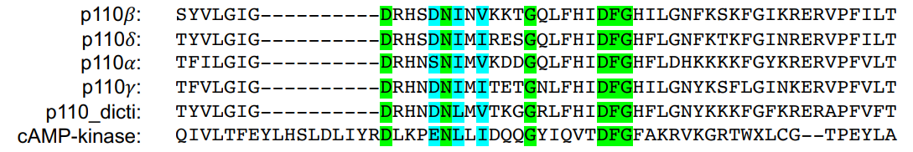

1. **Outline two different representations of the conserved positions, which can be used to search other sequences.** Consensus sequence,position specific similarity matrices
2. **Discuss relative advantages and disadvantages of the chosen representations for assigning function to novel sequences.** *Consensus sequence*, limitation: we can only have one resident one particular letter representing each position so we're very limited in what we can capture. *position specific similarity matrices* which are a little bit more intricate and have a little more functionality, as we can look at the variability within a particular position like different options for a particular position, as well as a numerical estimate for those.

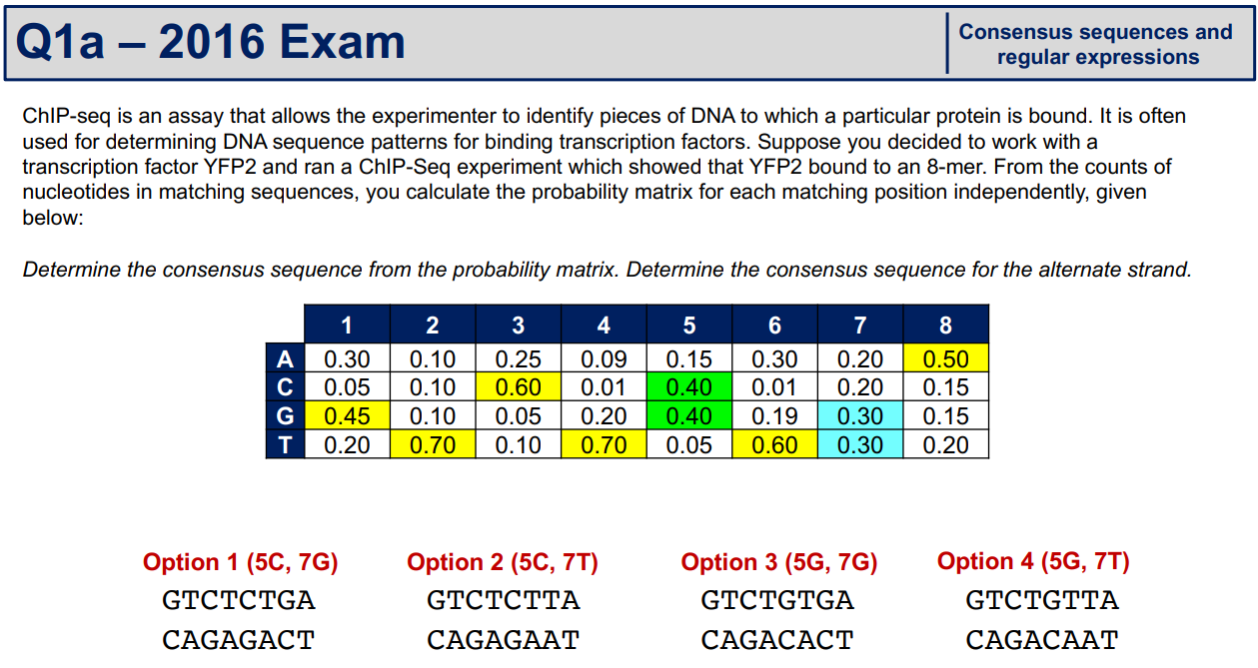 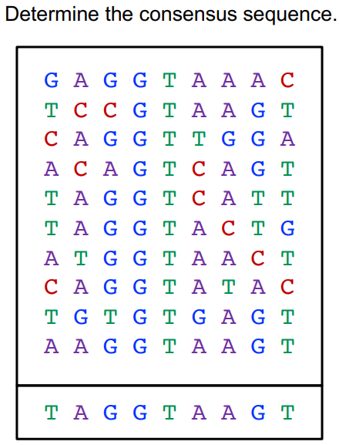 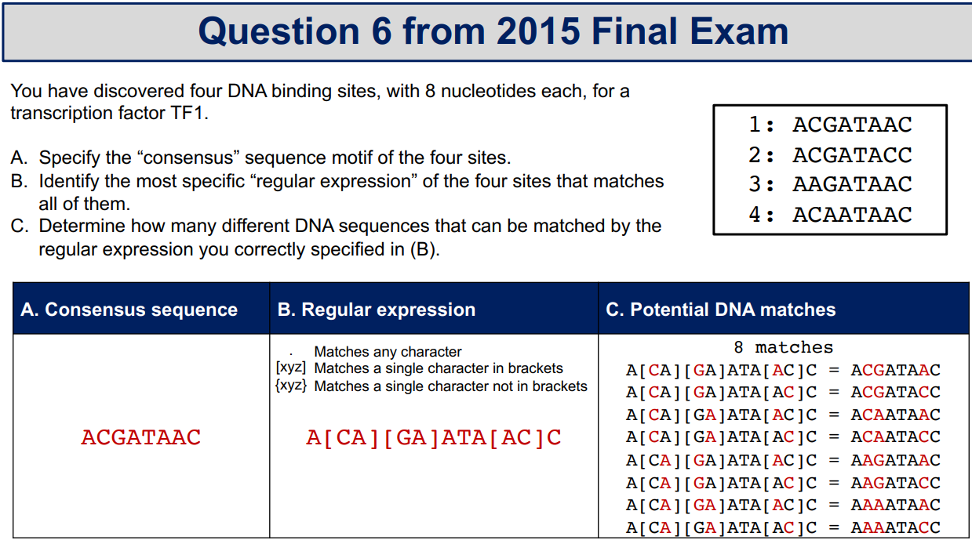

**A position weight matrix for a motif is shown below. Based on the information provided, identify the position in sequence X where the motif is most likely to occur, and the score of this motif match.**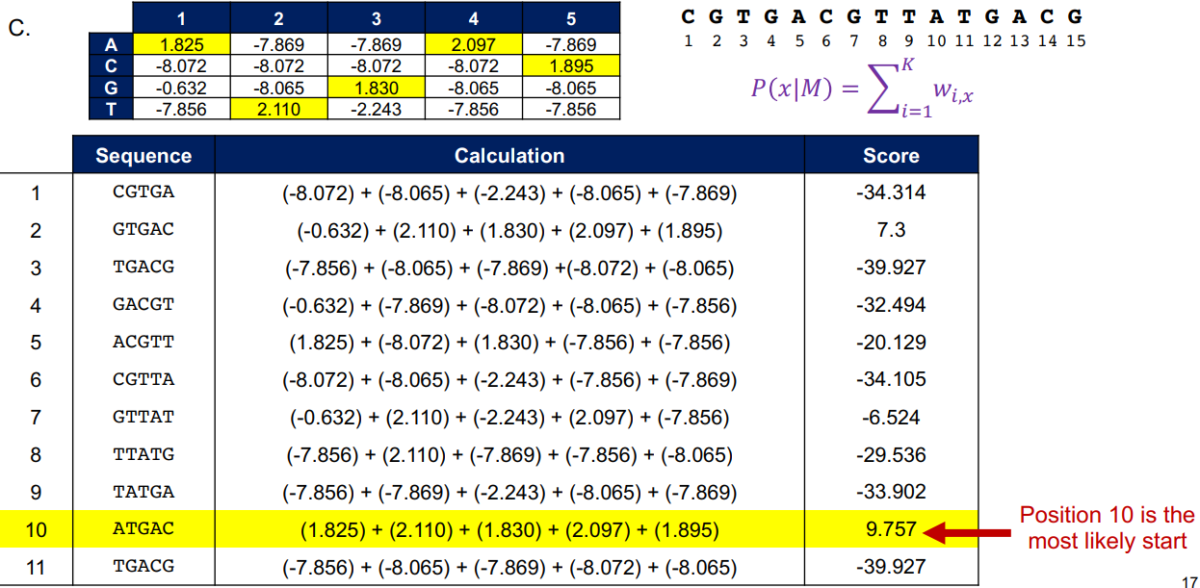 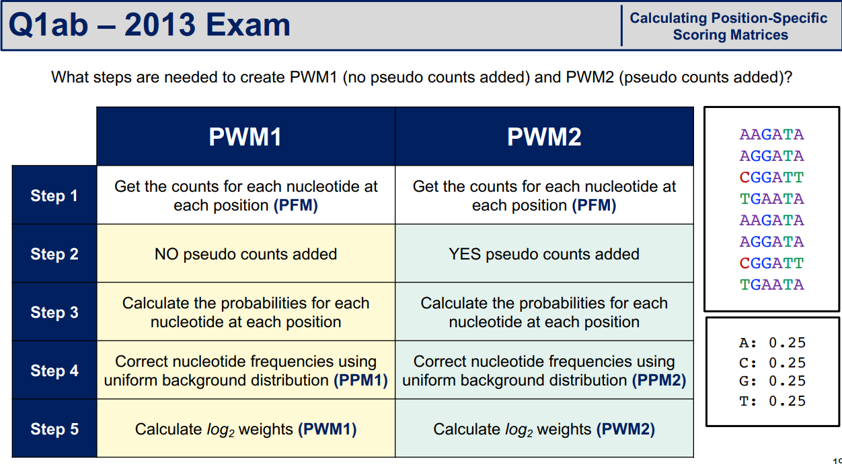

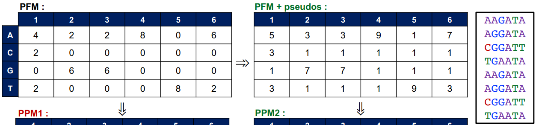 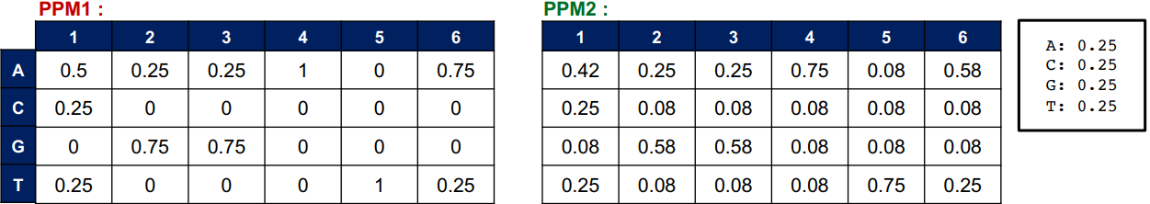

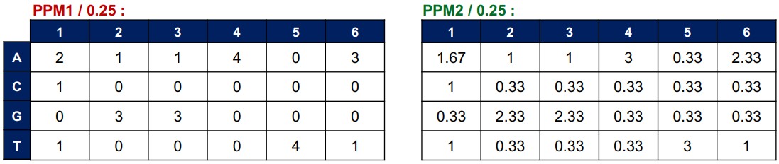 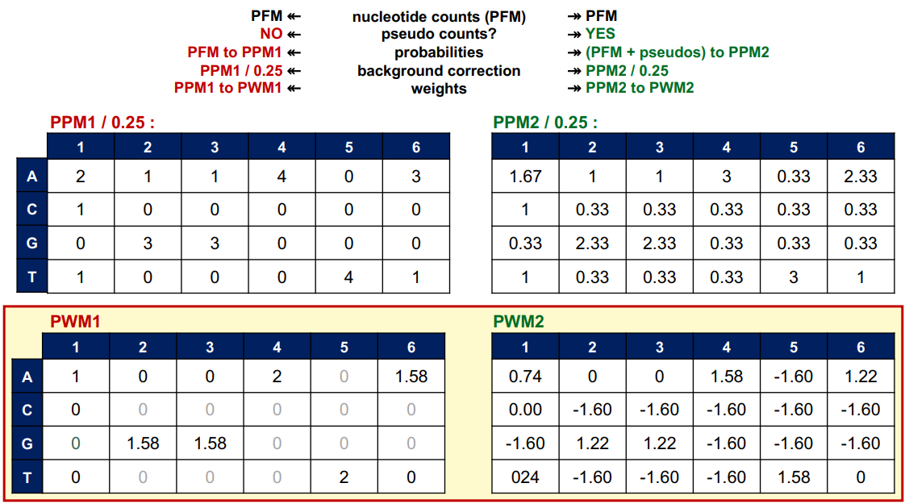

Note: the final step is doing a log base 2 on PPM

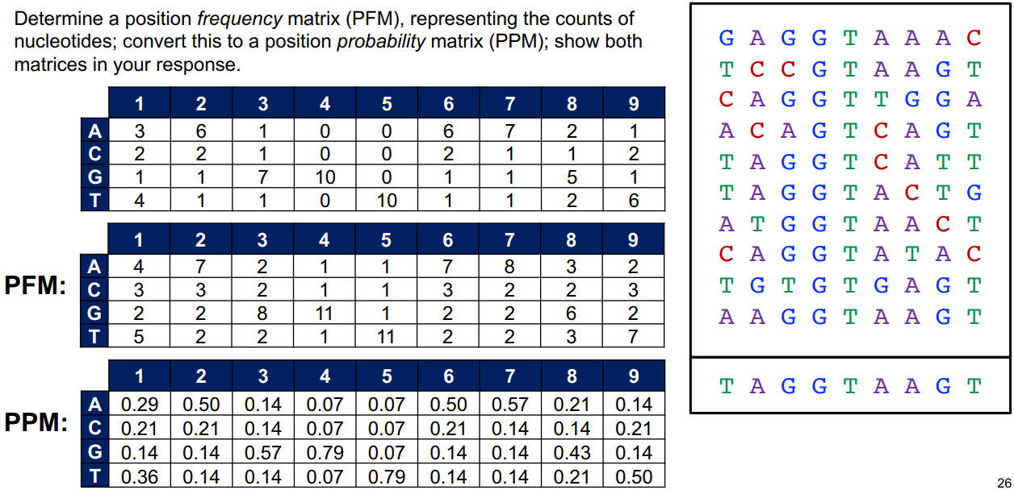 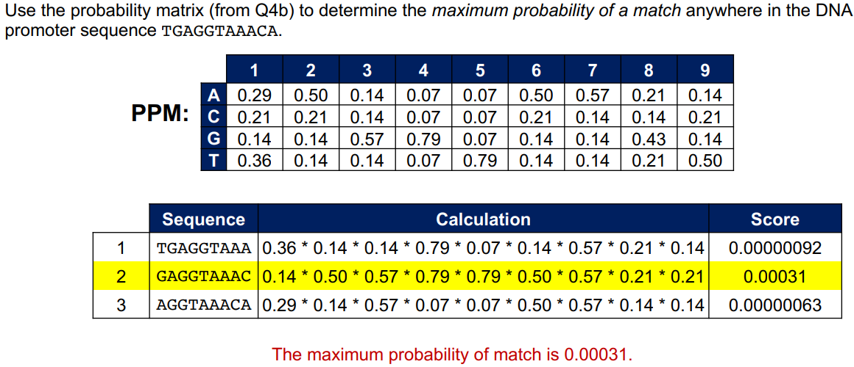

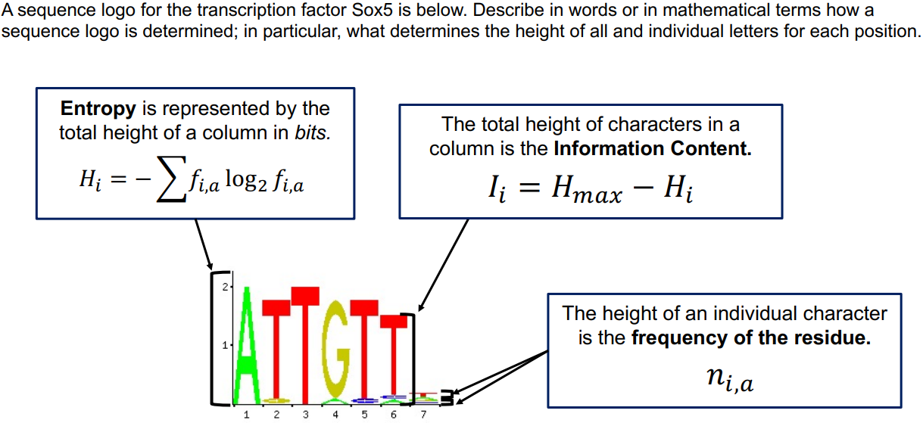 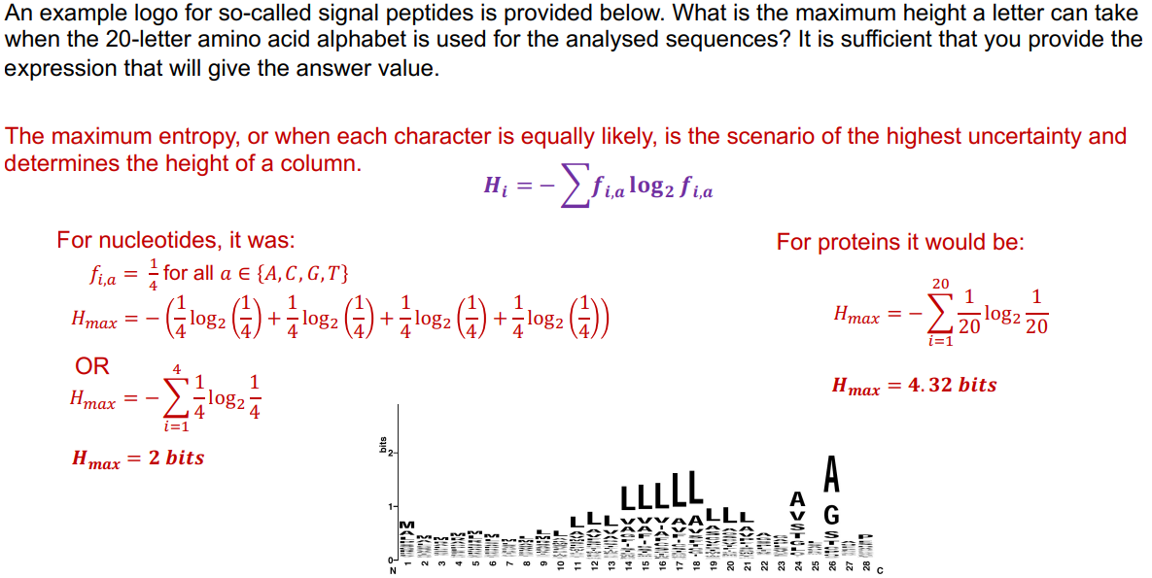

**Gene Expression Analysis**

1. **Name two technology platforms for generating high throughput gene expression data.**

RNA-Seq and Microarray

1. **What is the name of the largest repository that houses publicly available gene expression data?**

GEO (database within NCBI)

1. **For a given list of genes, a common approach is to investigate whether a specific pathway is enriched in this list. What is the statistical test used for over-representation analysis to determine whether the enrichment of a pathway is significant?** Fisher’s exact test or hypergeometric test
2. **Two genes are said to be differentially expressed when their gene expression profiles are different between two groups. What is the statistical test often used to determine whether two genes are differentially expressed?** T-test or limma

**The plot below shows the gene-expression distribution for Gene A in a population of 1000 cells, as observed in a single cell RNA-sequencing experiment.**

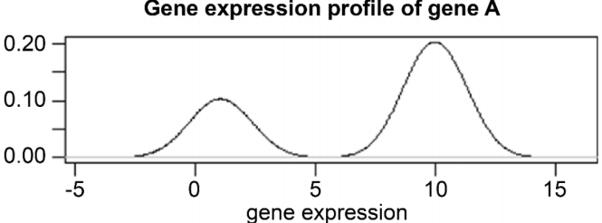

**Based on the information contained in this plot, identify the statement that is TRUE.**

1. **Gene A is alternatively spliced into two different isoforms.**
2. ***🡪 There are two sub-populations within the 1000 cells that express different levels of Gene A.***
3. **Gene A is differentially expressed.**
4. **The probe-set for Gene A shows non-specific binding.**

**Phylogenetics**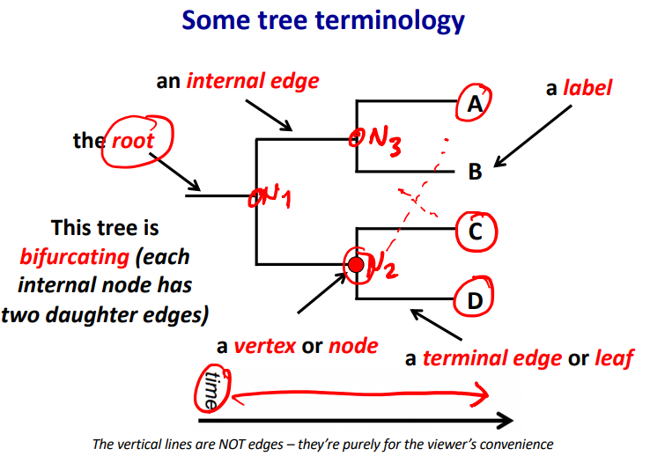

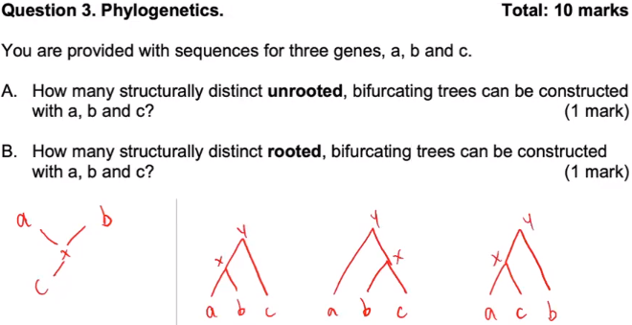 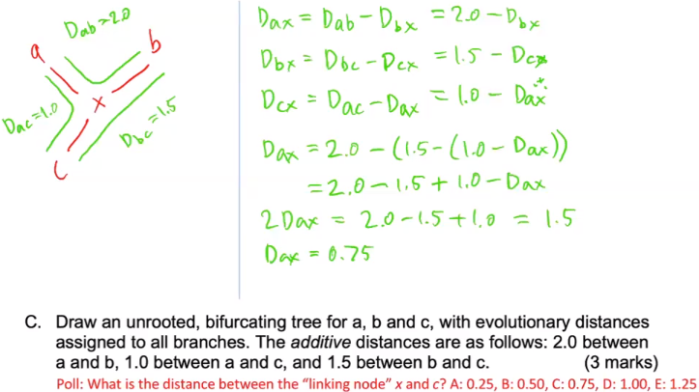

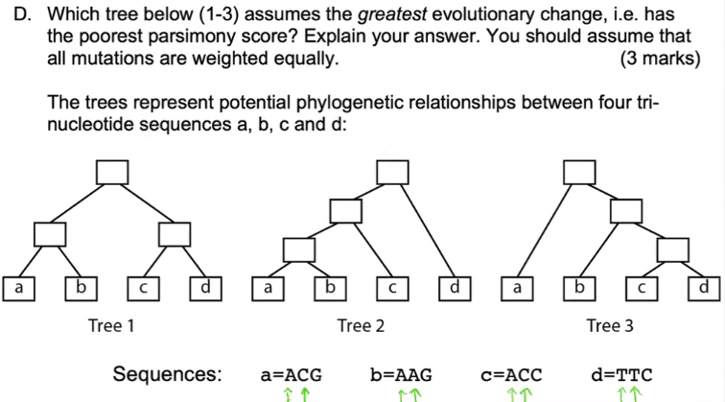 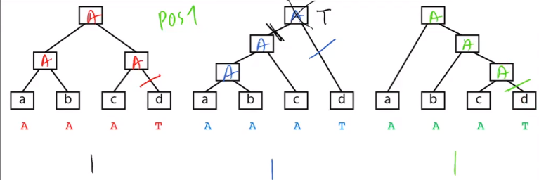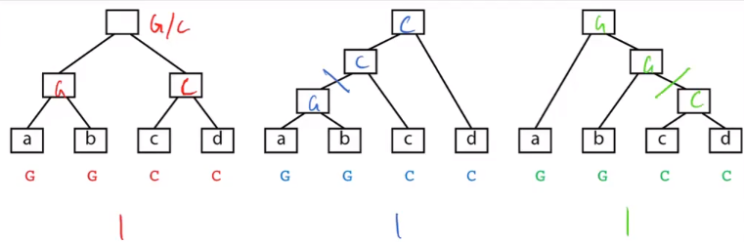 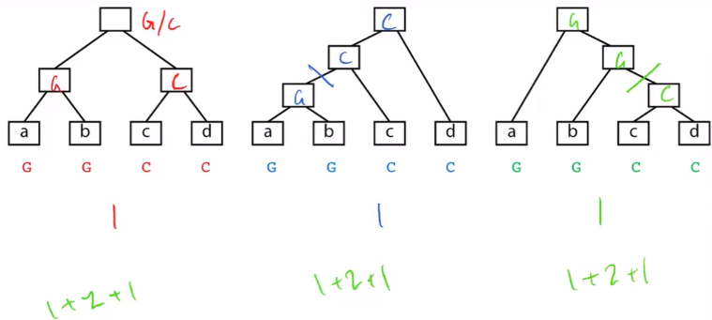

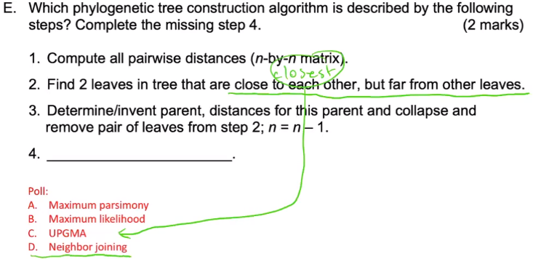

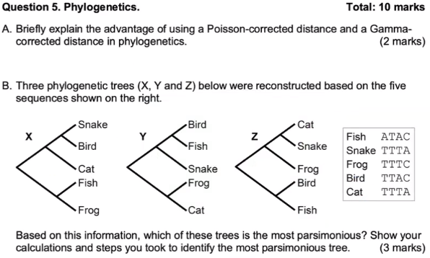 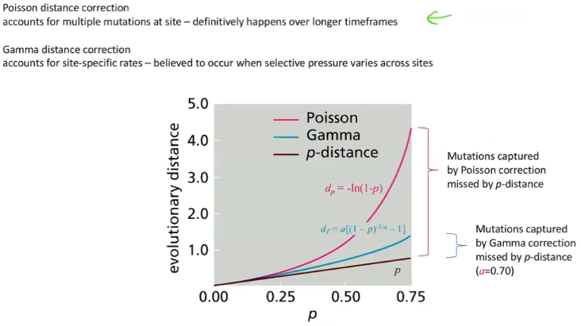

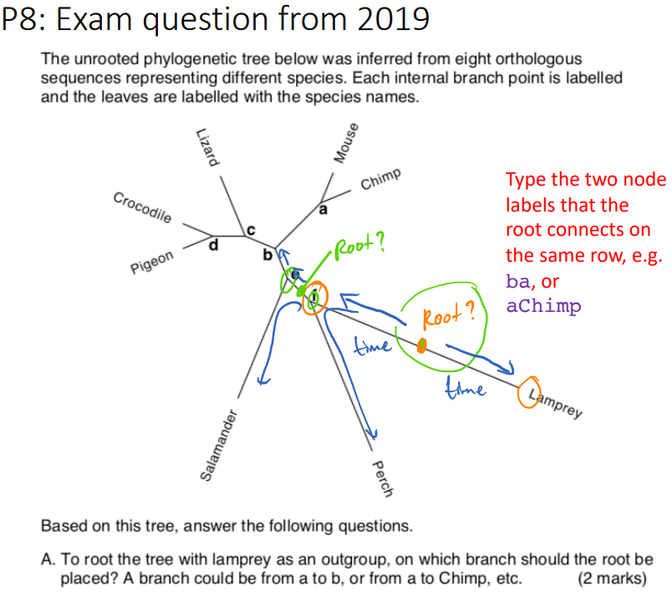 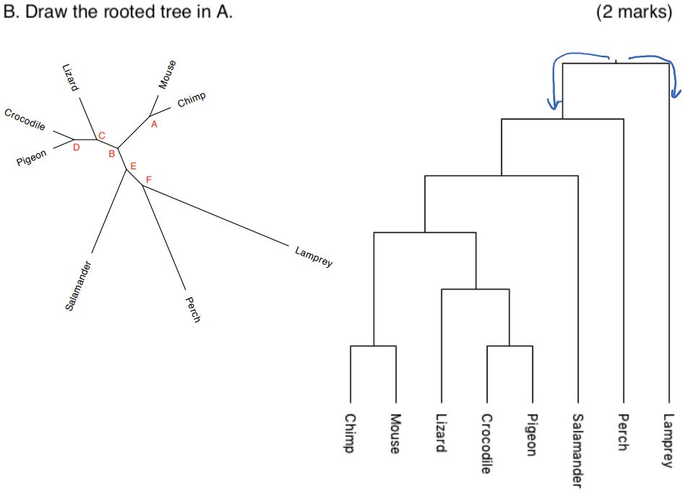

**To use molecular data to reconstruct evolutionary history requires making a number of reasonable assumptions. Which of the following statements are INCORRECT?**

The molecular sequences used in phylogenetic construction are homologous. The molecular sequences used in phylogenetic construction share a common origin. Parent branch splits into two or more daughter branches at any given point.

**Genome Analysis**

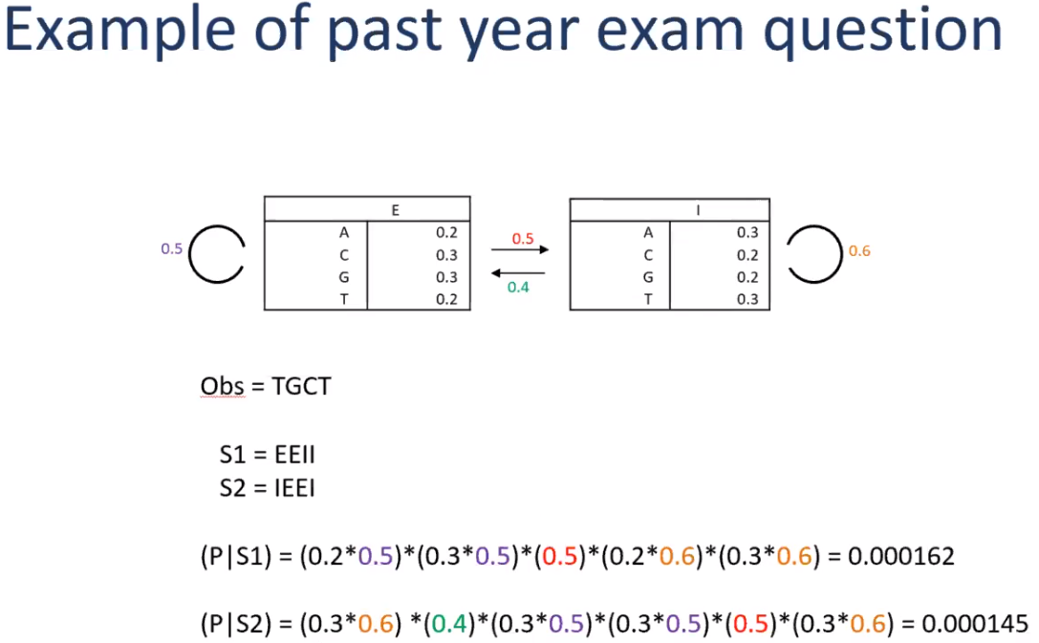

**Name two computational approaches for gene finding.**

Identity search, Similarity search- Homology based, Ab initio approaches

**Name three specific sequence features of eukaryotic genes that can be incorporated into a Hidden Markov model for predicting protein-coding genes.** Exons and introns, Regulatory sequences (promoter and enhancer), Splice donor and accepter sides, 5’ Cap and 3’ PolyA tail

**You are designing a Hidden Markov model for the identification of protein-coding genes in eukaryotic genomes. Which specific sequence characteristics of protein-coding genes could be included in the model and how would you train the model?**

**Biological databases**

**Name two tasks that you can perform using a database of biological sequence**

To identify homologous sequence; primer design; find molecular function.

**You have been given the amino acid sequence of protein known as BraC. You have been asked to find as much information as possible about BraC.**

**Describe what types of biological databases that are available for your research and the types of information they will provide.**

NCBI -> Run BLAST -> shared similarity to other known protein sequence in the database (homologous sequence) -> based on the hormone sentences if they're similar, it's likely to infer the same function

UniProtKB -> Run BLAST

PDB -> based on sequence of morality, you would get protein structure information

Annotation database -> protein function, PTM, localization

Literature (PubMed) -> what studies have been done on this protein

**Ontology**

**Briefly explain “ontology” and name TWO reasons why ontology is important for organising biological data.** Standardised vocabulary that defines concepts/terms and their relations or constraints in a domain (knowledge / field / discipline).

* Share common understanding
* Reuse and recycle knowledge
* Make assumptions explicit (no ambiguity)

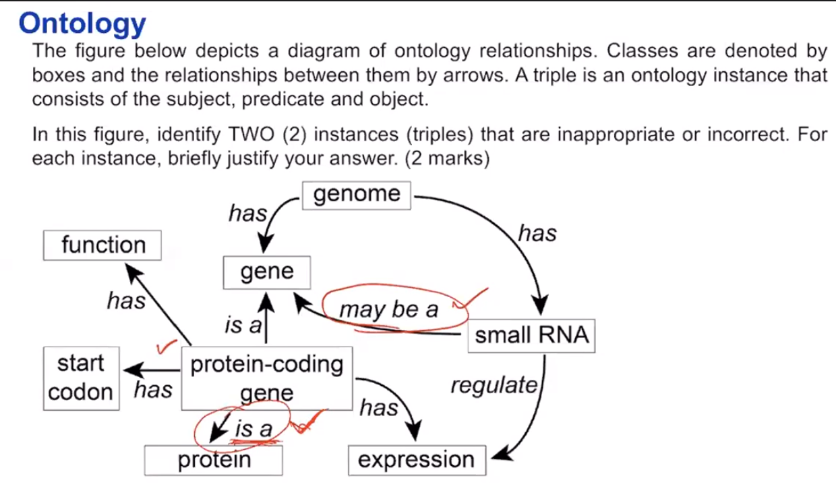 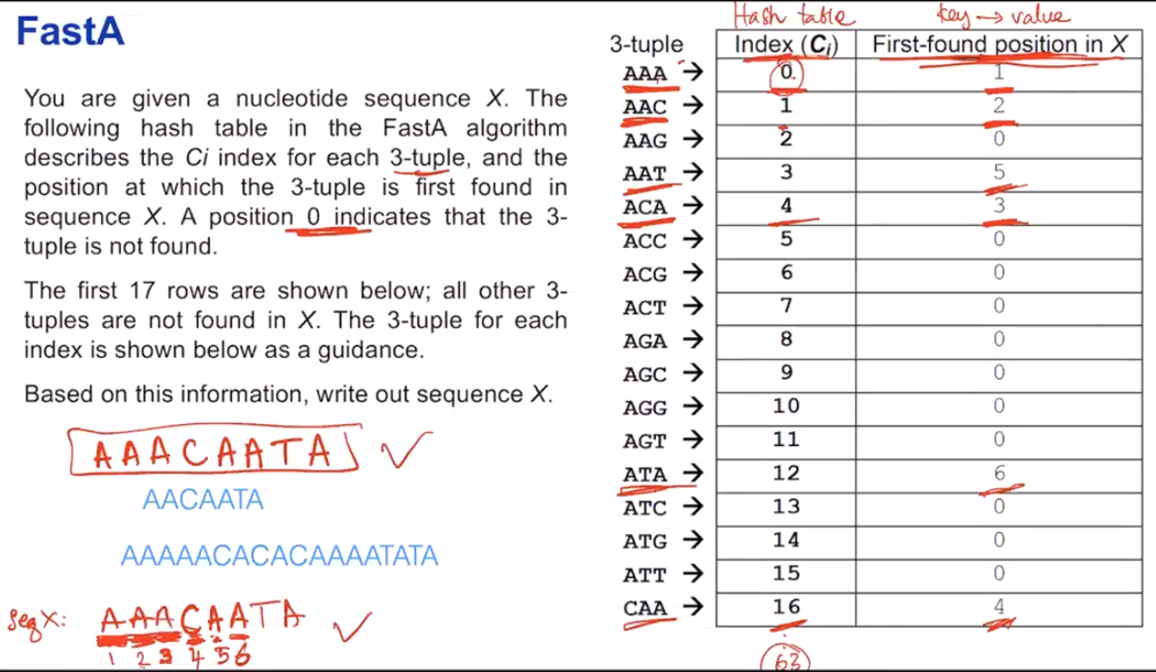

**A BLAST search result with an E-value of 0.001 must be significant. Regardless of which database we use in the search. Do you agree with the statement above? Please justify.**

Disagree. Database size matters -> it affect E-value

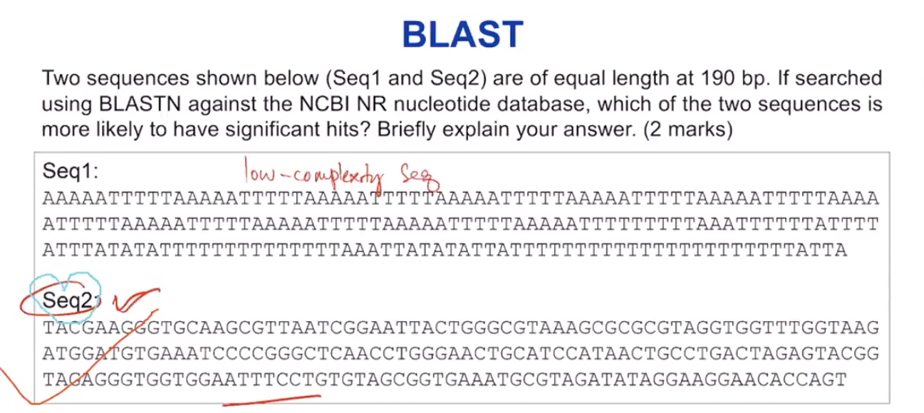

The key thing here is brings us back to the low complexity masking with blast, obviously you can see sequence one only has A and T, so this is a low complexity sequence. And even if you find any hits it would not be biologically meaningful can really know for sure how meaningful that particular match that would be. Whereas, in sequence two, it seems like a normal DNA sequence to me, and that if we find a hit in a database, it’s more biological meaningful.

**BLAST has a higher specificity that the FastA algorithm when searching for homologous sequences in a large database, because the masking of low-complexity regions in BLAST reduces potential false positives. Do you agree? Justify.**

Masking of low complexity, the region is to reduce false positive. Sequences just being identical by chance, we want to avoid that, which is why we mask all the low complexity regions generally and loss.

**Name two examples of biological data types.** Sequences, graphs

**Name two characteristics/factors that would affect how a user use a database.** Type of data, Availability

**Two key challenges in the maintenance of biological databases are the** shareable **and** interoperable **of these data among diverse laboratories and computer systems or platforms.**

**Name two main functions of biological databases.** Make biological data available to scientists, Make biological data available in computer-readable form

**Name two main applications of biological databases in bioinformatics.** Identification of biological entities, Inference of function

**What is an ontology? What is a main characteristic of an ontology?** Ontology defines (specifies) the concepts, relationships, and other distinctions that are relevant for modelling a domain. It takes the form of the definitions of representational vocabulary (classes, relations etc.), which provide meanings for the vocabulary and formal constraints on its coherent use.

**Why do we need ontology? Give two reasons.** It used to share common understanding of the structure of information among people or software agents, to enable reuse of domain knowledge, and to make domain assumptions explicit.

**What is basis for constructing an ontology triple?** Subject, predict, object

**Name two examples of ontology databases.** Reactome, KEGG

**Protein bioinformatics**

**What is protein secondary structure and how can we predict it? Why is it useful?**

Local structural classes (3- or 8-class; alpha, beta, coil). By statistics collected over “window”. Chou-Fasman. Starting point for prediction of tertiary and quaternary structure. Insights into biological function of protein. Facilitate alignment for homology modelling of distantly related proteins.

**How can we find protein-protein interactions, by experiment and by bioinformatics? Binding sites?**

By homology, Conservation (maybe spread in sequence but come together in structure); Many same-charged residues (electro-static interaction); Hydrophobic patch (unusual at surface; interaction by hydrophobic forces).

**What is a biological network? Exemplify what nodes and edges may mean.**

Flexible, joint representation of multiple components (nodes) in a system, with topology reflecting their relationships (edges); can be interaction, pathway, or causal/regulatory relationships.

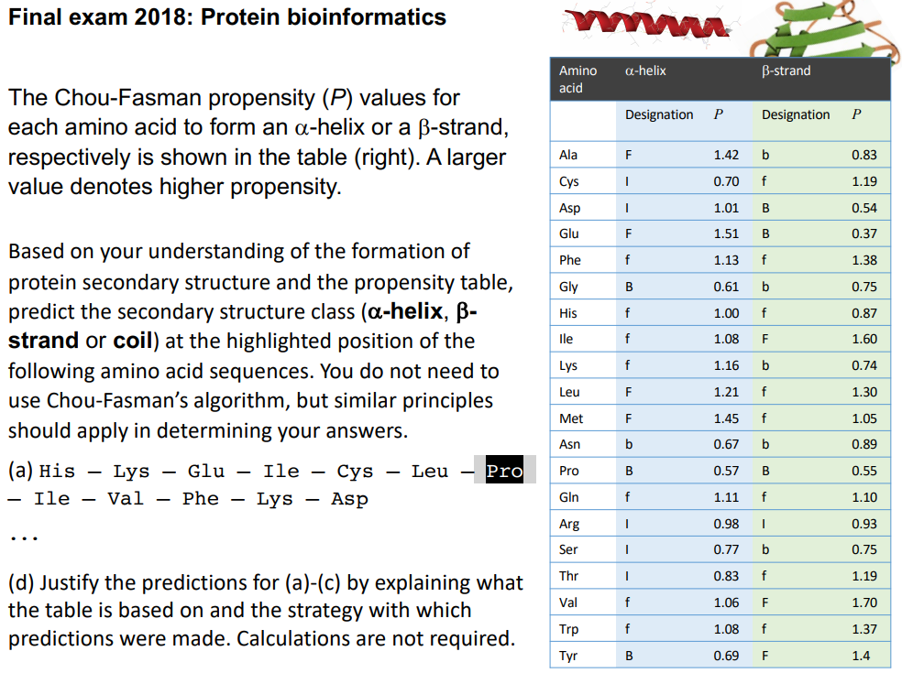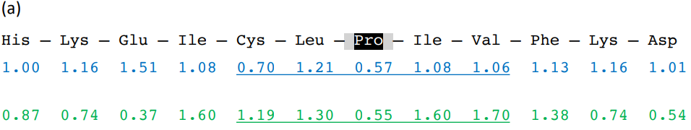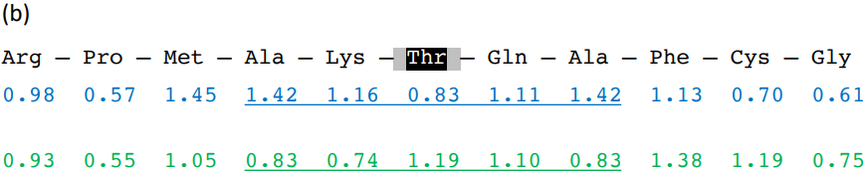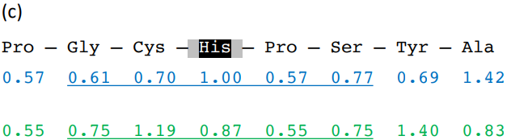

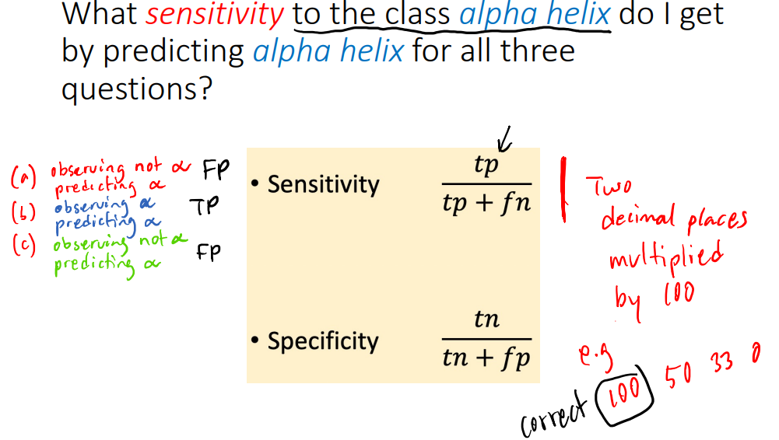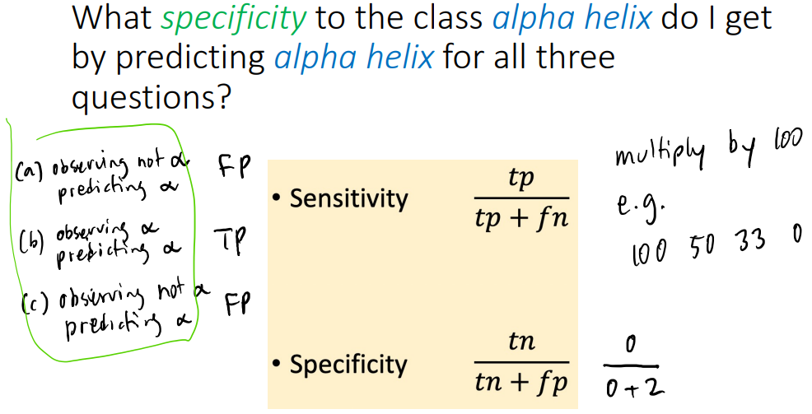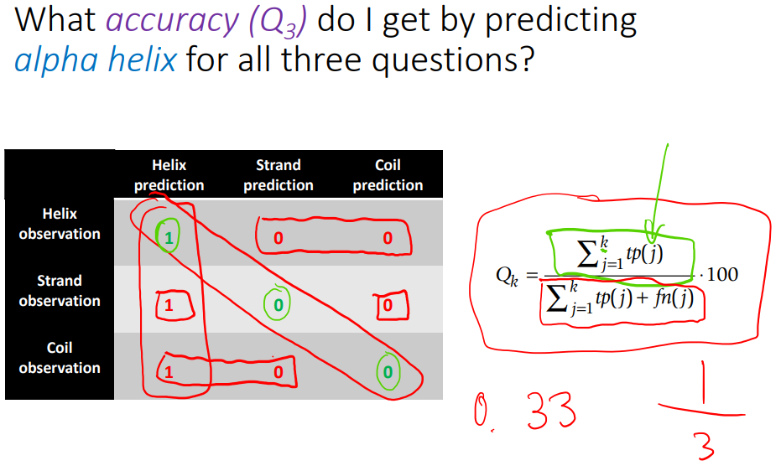

**TRUE:**

Pathway databases are never static, and entities are regularly updated.

Molecular clock is an assumption where the rate of evolutionary change of any specified protein is approximately constant over time and over different lineages.

Gene Ontology describes the attributes of genes and gene products. It does not represent protein structures, gene regulatory networks and biological pathways

Ontology in biology is a systematic, unambiguous description of specific biological attributes.

Sequence ontology describes features and attributes of biological sequences, e.g. binding sites, and exons.

BioPax describes attributes of biological pathways, not packaging of biological materials

FastA adopts the hashing-and-chaining algorithm to identify k-mers for seeding an alignment.

FastA algorithm uses only exact matches

Significance of the expect (E) value in BLAST is dependent on the size of the database

The BLAST algorithm searches for high-scoring segment pairs that are statistically significant

Low-complexity regions are usually masked in BLAST searches

Short DNA or amino acid sequences can carry functionally significant meaning– E.g. nuclear localisation signals and transcription factor binding sites

They are challenging to discover due to: – Random locations in genome/protein sequence – Degeneracy

Motifs can be represented both: – Discretely (e.g. consensus sequence or regular expression) – Continuously (e.g. position probability matrix)

Aligning large sequences fails to pick up short sequence motifs with functional and structural features, e.g. localization signals, binding sites

Motif representations can be derived from motif members (sharing features)

– Manually, by alignment, informed exploration and/or by precise experimental methods

– Via databases storing profiles/motifs as regular expressions, PWMs and profile HMMs

– Using discovery methods like Gibbs and MEME (do not require prior alignment)

A “logo” visualises a sequence pattern

PWM scoring can be used to find motifs